

**Name : AZHAR ALI**

**CMS : 023-23-0314**

**SEC : A**

1. Implement selection sort and insertion sort.

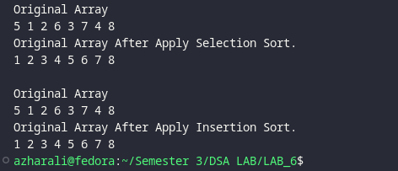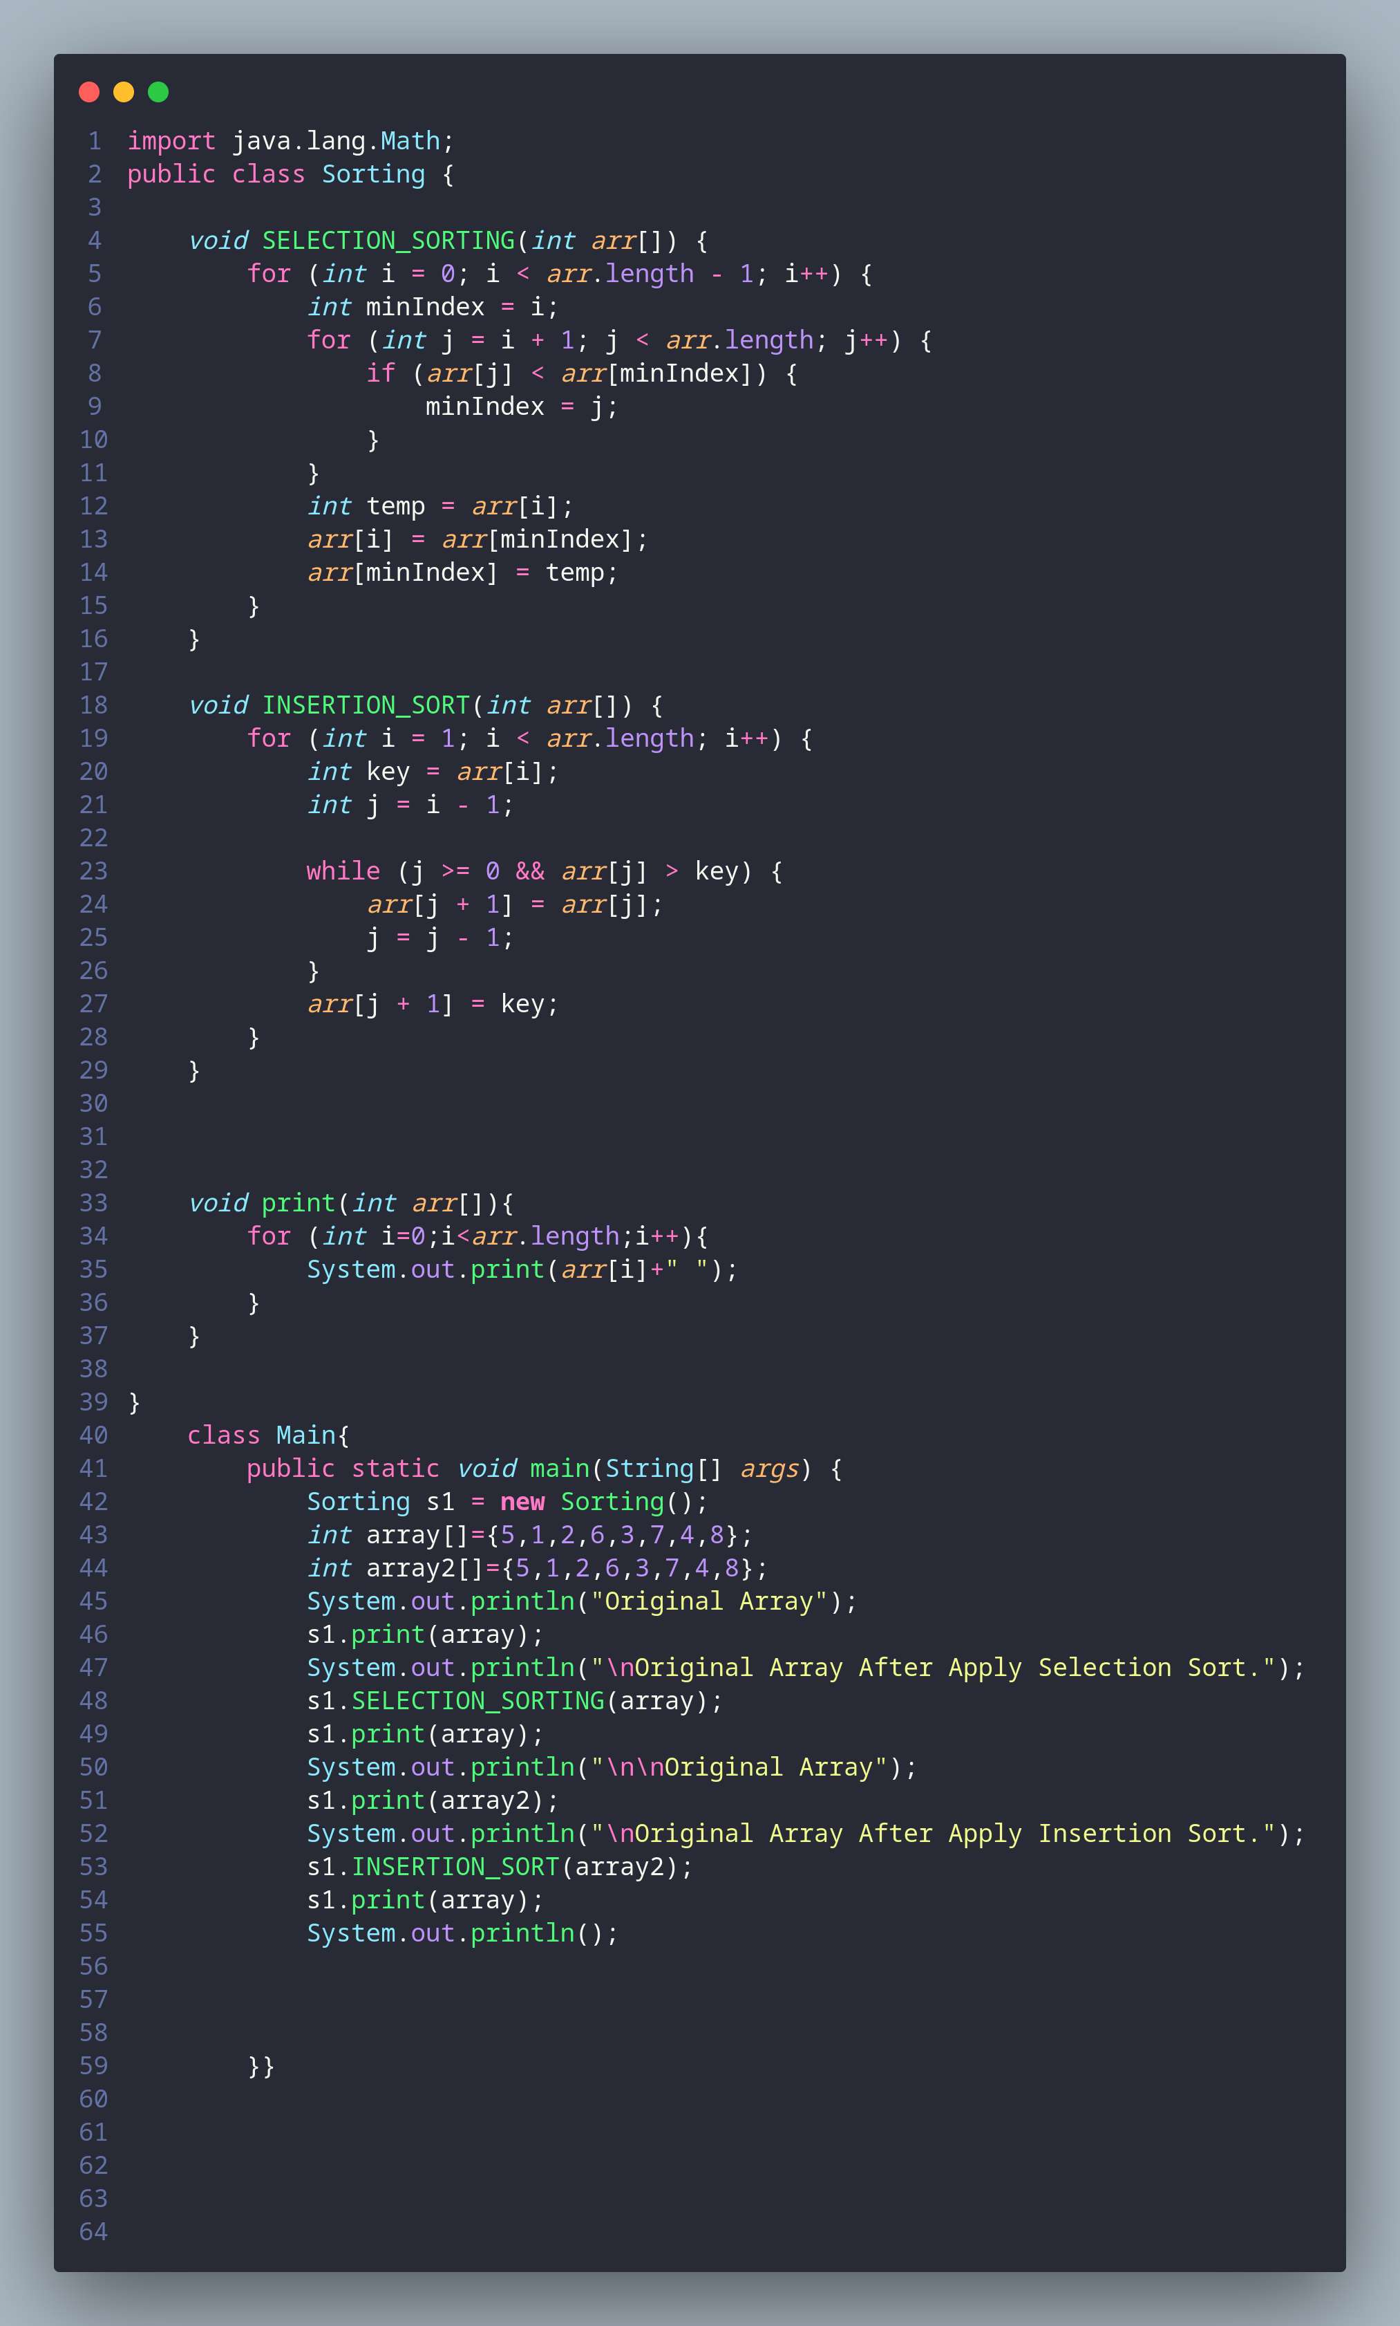

1. (Solve in NlogN): We are given an array that contains N numbers. We want to determine if   
   there are two numbers whose sum equals a given number K. For instance, if the input is 8, 4, 1,   
   and 6, and K is 10, then the answer is yes (4 plus 6 is 10). A number n may appear more than   
   once in the input array; in that case and only in that case the sum may have the form n + n.   
     
   Implement a function TwoSum() to solve this problem in O(N log N ) time.   
   Hint: Sort the items first!

